

Neutrosophic Optimization and Intelligent systems
Journal Homepage: sciencesforce.com/nois
Neutrosophic Opt. Int. Syst. Vol. x (xx) x–x.
Paper Type: Original Article
Paper Title

FirstName, LastName ¹,* , and FirstName, LastName

¹ Affiliation; Email Address;
² Affiliation; Email Address;

Received: 00 Jan 2024 Revised: 00 Jan 2024 Accepted: 00 Jan 2024 Published: 00 Jan 2024

Every paper should include an abstract with a maximum of 300 words. The abstract should include the problem explanation, methods used for the solution, and the significant results. It should finish with a sentence to describe the implications for the field. The abstract must not include references, figures or tables.
Keywords:(Sentence case and followed by colon) followed by 3 to 7 words that describe the focus and contribution of the paper.

Abstract

- |Introduction
The title of the paper should be written in Garamond bold 19-point font, left side on the top of the paper. The first letter of every word in the title should be capitalized. The authors’ names, following the title, must be written in Garamond bold 10 point font and their affiliations must be written in Garamond 9 point font.
All major headings are flushed with the left margin in Garamond. Headings 1 are capitalized, bold and in 16 fonts. Do not put a period after the text of the heading. Headings 2 are capitalized, bold and in 14 fonts. Headings 3 are sentence case and in 12 fonts. The whole paper should be written in “Garamond” font and 11 pt. Every paragraph should be justified. Line spacing at paragraphs should be multiple at 1.15 cm, and please leave one line space between two paragraphs. Please set the paper size as A4. Leave 1/75 cm margin at the top, 1 cm margin at the bottom of the page, 1.3 cm on both right and left sides. Please write your paper using Microsoft Office Word.
  - |Figures and Tables
Figures and Tables should be placed as close as possible to where they are cited. Captions should be Garamaod 10 points, bold, and in sentence case. Figures and Tables should be numbered separately and consecutively. Figure captions should be center-aligned below the figures, and table captions should be center-aligned above the table body.
All inserts, figures, diagrams, photographs, and tables must be center-aligned, clear, and appropriate for black/white or greyscale reproduction.

Figures (e.g., Figure 1) must be numbered consecutively, 1, 2, etc., from start to finish of the paper, ignoring sections and subsections. Tables (e.g., Table 1) are also numbered consecutively, 1, 2, etc., from start to finish of the paper, ignoring sections and subsections, and independently from figures.
Table contents and headers must be 10 pt. font, and left aligned.
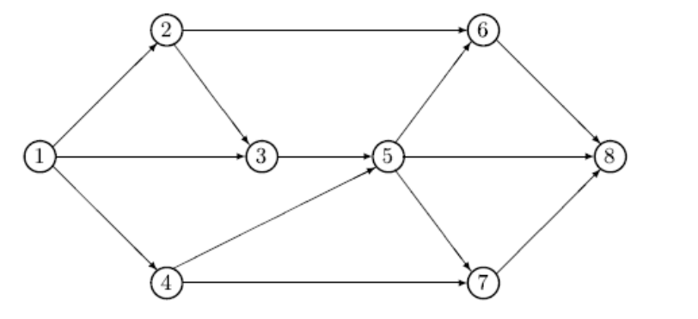

Figure 1. Network with eight vertices.

Table 1. List of Arc lengths.
S/N | Questions | Options
1 | How often does waste management team visit your locality for waste collection and disposal? | Once a week | Once a month
2 | How do you dispose your household waste? | Bury it in the ground | Burn it
3 | What (category) of waste is dominant in your daily household waste? | Food waste | Plastic waste

1.1.1| Variables and equations
All equations in-text should be Times New Roman font, and 10 pt. as the sample. All equations in separate tables should be placed on separate lines, Times New Roman font and 11 pt. numbered consecutively, and left aligned with the equation numbers placed within parentheses and aligned against the right margin as shown in Eq. (1).
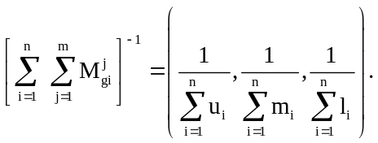 | (1)
Where
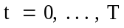, and b is a number greater than 1.
Be sure that the symbols in your equation have been defined before the equation appears or immediately following. Each equation should be written by MathType in specified style as shown in Eq. (1).
Note: For all equations produced by the Equation Tool, it is required to use the Cambria Math font with a font size of 10 pt. for in-text and 11 pt. for numbered equations.

Acknowledgments
Acknowledgements enable you to thank all those who have helped in carrying out the research. Careful thought needs to be given concerning those whose help should be acknowledged and in what order. The general advice is to express your appreciation in a concise manner and to avoid strong emotive language.

Author Contributaion
For research articles with multiple authors, provide a short paragraph that identifies each contribution. The following statements should be used: "Conceptualization, X.X. and Y.Y.; Methodology, X.X.; Software, X.X.; Validation, X.X., Y.Y. and Z.Z.; formal analysis, X.X.; investigation, X.X.; resources, X.X.; data maintenance, X.X.; writing-creating the initial design, X.X.; writing-reviewing and editing, X.X.; visualization, X.X.; monitoring, X.X.; project management, X.X.; funding procurement, Y.Y. All authors have read and agreed to the published version of the manuscript. Authorship must be limited to those who have made a significant contribution to the work reported. All terms were described in the CT file.

Funding
This section indicates any support that is not included in the Author Contribution or Funding sections. This may include administrative and technical support or in-kind donations (e.g., materials used for experiments).

Data Availability
We encourage all authors to make their research data available. Please indicate where the data supporting the reported findings can be found, including links to publicly archived datasets that were analyzed or generated during the study. If no new data were generated or if data are not available due to privacy or ethical restrictions, an explanation is still required. The suggested Data Availability Statements were collected in DAS file.

Conflicts of Interest
The authors declare no conflict of interest. Authors must declare any personal circumstances or interests that could be considered to have an inappropriate influence on the presentation or interpretation of the reported research findings. Any role of funders in the design of the study, in the collection, analysis, or interpretation of the data, in the writing of the manuscript, or in the decision to publish the results must be disclosed in this section. If this is not the case, please indicate "Funders played no role in the design of the study, in the collection, analysis, or interpretation of the data, in the writing of the manuscript, or in the decision to publish the results." You can see more details in CID file.

References
Text. Indicate references by number(s) in square brackets in line with the text. The actual authors can be referred to, but the reference number(s) must always be given.
List. Number the references (numbers in square brackets) in the list in the order in which they appear in the text. References should be written in Palatino Linotype 9 pt. font and multiple line spacing at 1.15.
Reference to a Article
- Youssf, O., ElGawady, M. A., & Mills, J. E. (2016). Static cyclic behavior of FRP-confined crumb rubber concrete columns. Engineering structures, 113, 371-387. https://doi.org/10.1016/j.engstruct.2016.01.033
Reference to a Book
- Liao, H., & Xu, Z. (2017). Hesitant fuzzy decision making methodologies and applications. Springer Singapore.
Reference to a Book Chapter
- McKenzie, R.B. (2018). From robbins to friedman and beyond. In A brain-focused foundation for economic science (pp. 63-92), Palgrave Macmillan, Cham. Springer. https://doi.org/10.1007/978-3-319-76810-6_3
Reference to a Conference Proceeding
- Hakani Raj, A. (2010, May). Development of an intelligent sensor based inspection robot for closed environment. Proceedings of the 2015 5th Nirma University international conference on engineering (NUiCONE) (pp. 1-6). IEEE.
Reference to a Website
- Murphyn, L. (n.d.). Utrition & exercise - timing is everything. NASM. https://blog.nasm.org/workout-and-nutrition-timing

Appendix
Authors can use supplementary sections, known as Appendixes, to provide additional information supporting the findings presented in their manuscript. These Appendixes serve the purpose of including details that might disrupt the main text's flow or are only relevant to a specific subset of readers. The supplementary sections may encompass comprehensive mathematical proofs, extra figures, more in-depth experimental particulars, or supplementary data.
When citing an Appendix in the main text, it is essential to reference it accordingly. In the Appendix, any referenced Figures, Tables, equations, etc., should be labeled with an "A" prefix, followed by a sequential numbering starting from 1 (e.g., Fig. A1, Fig. A2, etc.).

